First Passive Acoustic Monitoring Strategic Initiative Workshop Report

La Jolla, California

Matti Meikäläinen

Ashok Kumar

2024-03-01

Table of contents

# Citation

PAM-SI Meeting Repository

# 1. Introduction to Meeting Attendees

## 1.1 Example:

### 1.1.1 [Insert Image] Name, *Institution* (using Header 3)

Write ~ 3 sentences about yourself (the work you do, what you do for fun). Bonus if you’d like to cite a favorite publication (yours or others).

## 1.2 For detailed instructions, see [OpenScience website](https://sael-swfsc.github.io/OpenScience/content/prep/PAM-SI-Mtg-Prep-step4.html)

## 1.3

### 1.3.1

### 1.3.2 Cory Hom-Weaver, [*SWFSC*](https://www.fisheries.noaa.gov/west-coast/science-data/southwest-acoustic-ecology-lab)

Cory started working as an acoustic ecologist at SWFSC in 2020. During her time at the center, her research has focused the detection and classification of baleen whales in the California Current Ecosystem. She is also interested in technological development of passive acoustic monitoring systems. In her free time she loves to surf, cook and hike.

### 1.3.3

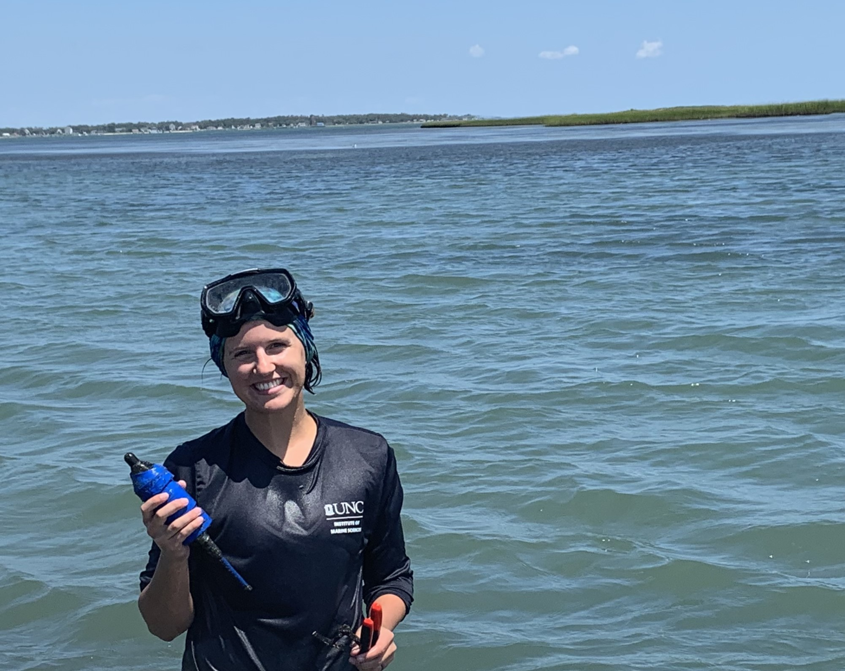

### 1.3.4 **Becca Van Hoeck*,*** [NEFSC](https://www.fisheries.noaa.gov/new-england-mid-atlantic/endangered-species-conservation/passive-acoustic-research-atlantic-ocean)

Becca coordinates the Inflation Reduction Act funding the NEFSC Passive Acoustic Branch received for the PAM Strategic Initiative and North Atlantic right whale monitoring. She also conducts research and participates in regional coordination related to offshore wind energy development focused on fish and soundscapes. Outside of work, she spends her time reading fiction, spending time outside, and wrangling her two year old son.

### 1.3.5

### 1.3.6 **Megan McKenna*,*** [CIRES-NCEI](https://www.ncei.noaa.gov/products/passive-acoustic-data)

Megan works with collaborative teams collecting PAM data, currently with the SoundCoop and previously with SanctSound. Megan helps to unravel these complex data by applying analytical tools- both new and existing- into standardized data processing pathways. While interested in metrics that look at the whole soundscape, vessel noise is often a focus. Megan also teaches graduate classes on marine science and policy at Middlebury Institute of International Studies in Monterey. When not working, Megan is out exploring the beautiful central coast of California with her family.

### 1.3.7

### 1.3.8 **Shannon Rankin*,*** [***SWFSC***](https://www.fisheries.noaa.gov/west-coast/science-data/southwest-acoustic-ecology-lab)

Shannon leads the Southwest Acoustic Ecology Lab at SWFSC in La Jolla. She has worked with a variety of marine mammals (from vaquita to blue whales, and most everything in between) using mobile PAM platforms: towed arrays, sonobuoys, drifting buoys, and this year she’ll begin to work with gliders.

# References